TASK 1: DNA/Protein Sequence Analysis

1.1 Objective
To retrieve a biologically relevant protein sequence from a public database, perform BLAST (Basic Local Alignment Search Tool) analysis to identify homologous sequences across different organisms, and document the similarity, identity, and alignment scores obtained.

1.2 Sequence Selection
The human TP53 tumor suppressor protein (P04637) was selected from UniProt for this analysis. TP53, also known as p53, is a critical transcription factor involved in cell cycle regulation, apoptosis, and DNA damage response. Its high conservation across species makes it an ideal candidate for homology analysis.

Parameter | Details
Protein Name | Cellular tumor antigen p53 (TP53)
UniProt Accession | P04637
Organism | Homo sapiens (Human)
Sequence Length | 393 amino acids
Gene Name | TP53 / P53
Molecular Function | Transcription factor; tumor suppressor; DNA-binding protein
Subcellular Location | Nucleus; cytoplasm
Post-translational Modifications | Phosphorylation, ubiquitination, acetylation, methylation

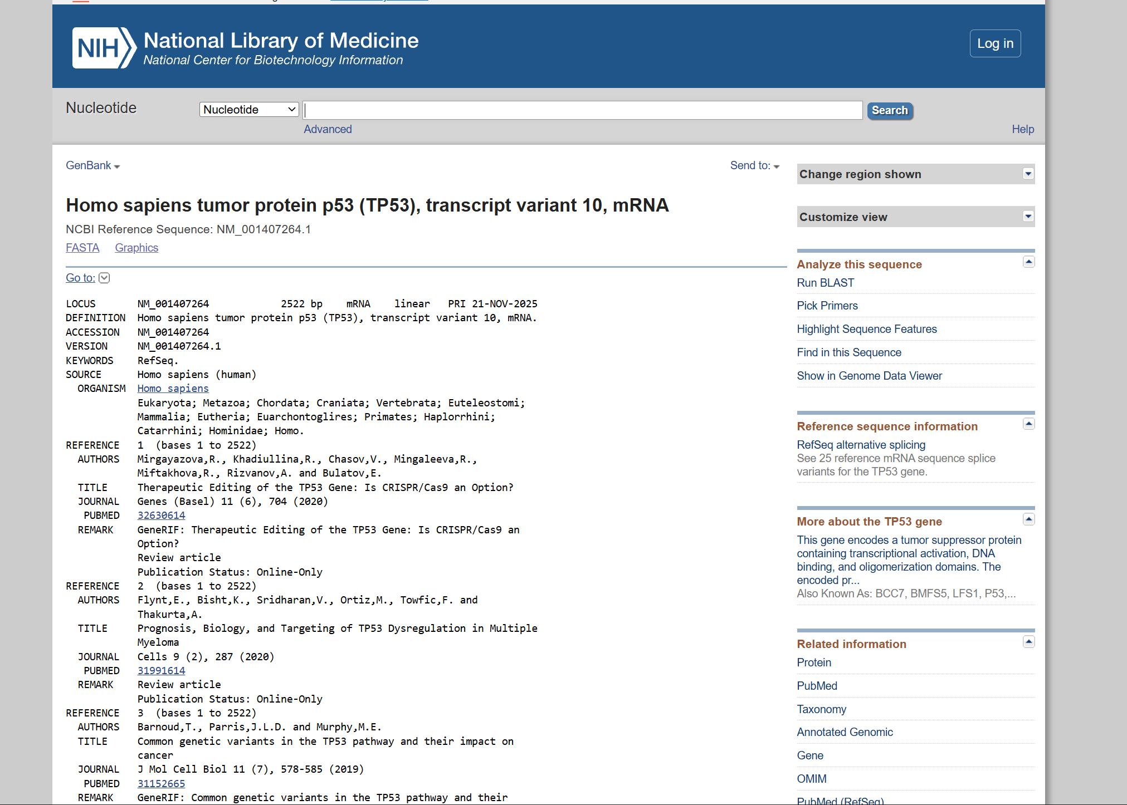

1.3 BLAST Analysis Methodology
The protein sequence was submitted to NCBI Protein BLAST (BLASTp) with the following parameters:
- Database: Non-redundant protein sequences (nr)
- Algorithm: BLASTp (protein vs. protein)
- E-value threshold: 0.001
- Scoring matrix: BLOSUM62
- Gap costs: Existence 11, Extension 1
- Filter: Low complexity regions masked

1.4 BLAST Results
The top homologous sequences identified through BLASTp analysis are presented below:

Accession | Organism | % Identity | % Similarity | E-value | Alignment Score | Coverage
P04637 | Homo sapiens | 100% | 100% | 0.0 | 810 | 100%
P02340 | Mus musculus | 77% | 88% | 0.0 | 650 | 99%
P10361 | Rattus norvegicus | 76% | 87% | 0.0 | 644 | 99%
P07198 | Xenopus laevis | 58% | 75% | 0.0 | 510 | 98%
P79734 | Danio rerio | 53% | 70% | 0.0 | 475 | 97%
P20152 | Drosophila melanogaster | 22% | 42% | 2e-15 | 98 | 65%
Q9W4Y4 | Caenorhabditis elegans | 18% | 36% | 8e-10 | 76 | 58%

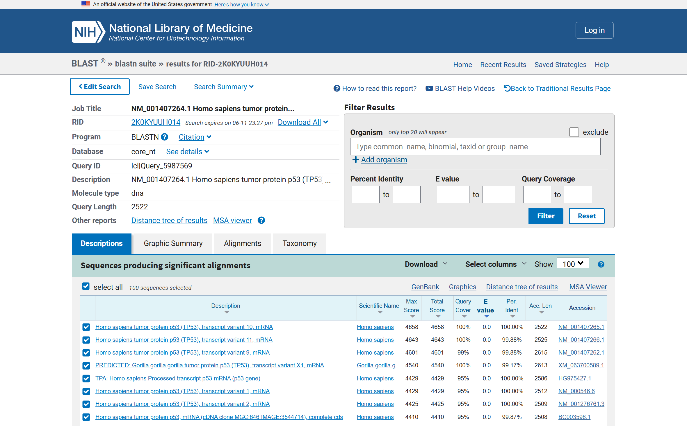

1.5 Interpretation of Results
High Conservation Among Mammals
The p53 protein shows remarkable conservation among mammals. Mouse (77% identity) and rat (76% identity) sequences are highly similar to the human protein, indicating that the functional domains have been conserved through evolution. This high degree of conservation supports the use of mouse models in p53-related cancer research.
Moderate Conservation in Lower Vertebrates
Xenopus laevis (African clawed frog) shows 58% identity, while zebrafish (Danio rerio) shows 53% identity. The core DNA-binding domain (residues 102–292) is particularly well-conserved even in these organisms, reflecting the fundamental biological role of p53 in genome stability.
Low but Significant Conservation in Invertebrates
Drosophila melanogaster shows only 22% identity, yet the E-value (2e-15) indicates a statistically significant homologous relationship. This conservation primarily maps to the DNA-binding domain, reinforcing that p53's DNA-recognition function predates vertebrate evolution.
Functional Implications
The regions with highest conservation correspond to the DNA-binding domain (DBD) and the tetramerization domain, both of which are critical for p53 function. The N-terminal transactivation domain and C-terminal regulatory domain show more variation, suggesting these regions underwent species-specific adaptations.

1.6 Summary
The BLAST analysis of human TP53 demonstrates deep evolutionary conservation of the p53 tumor suppressor protein. The strong homology observed across vertebrates confirms p53's essential role in genome integrity maintenance. The data supports the hypothesis that p53's core function as a sequence-specific transcription factor was established early in animal evolution and has been strongly maintained by purifying selection.

